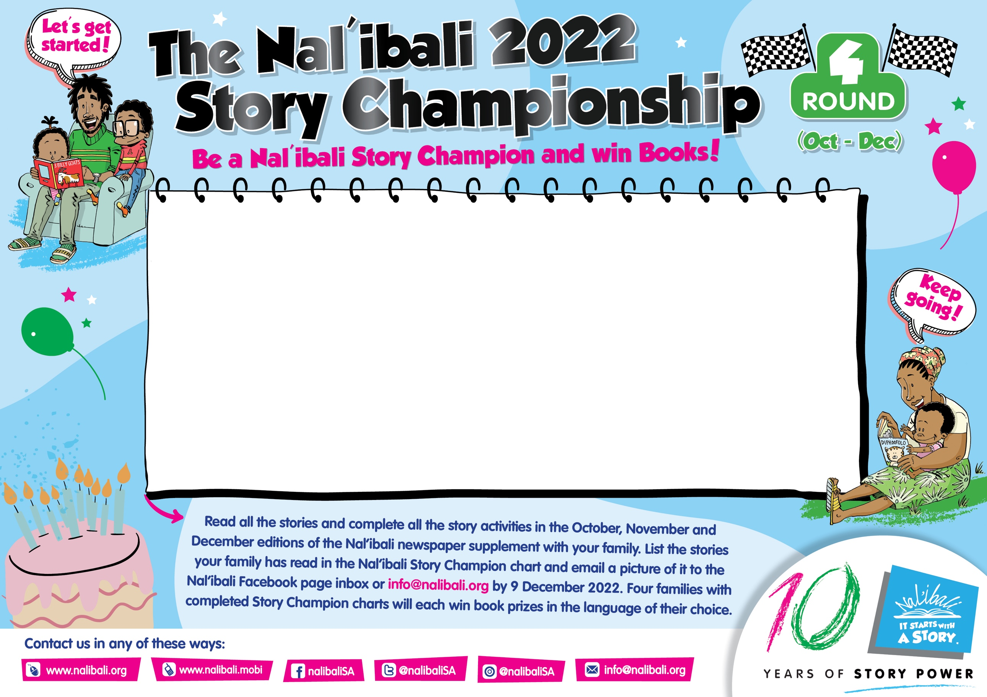

|  |  |  |
| --- | --- | --- |
| **EDITION** | **Story Title:** |  |
| **191** |  | **Complete:** |
| **191** |  | **Complete:** |
| **192** |  | **Complete:** |
| **192** |  | **Complete:** |
| **193** |  | **Complete:** |
| **193** |  | **Complete:** |